**Coursework2**

Name: Jiao Ruipeng

**Part1**

a) List the route number and frequency of the route operated by Moor-Dale Coaches. (1 mark)

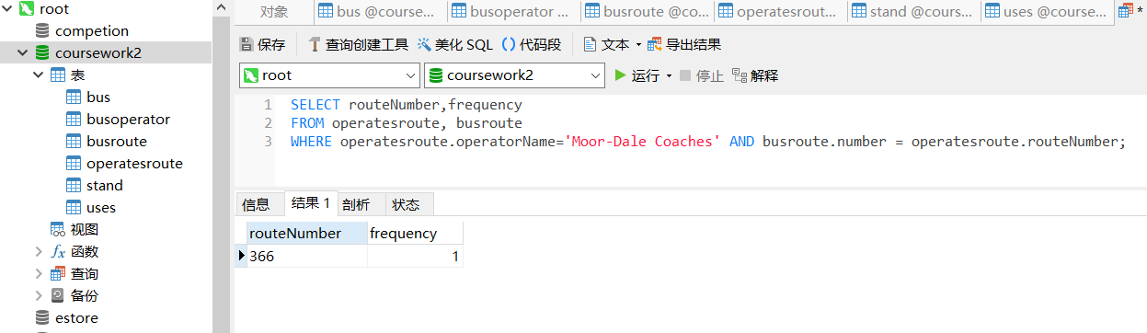

**A Code:**

SELECT routeNumber,frequency

FROM operatesroute, busroute

WHERE operatesroute.operatorName='Moor-Dale Coaches'

AND busroute.number = operatesroute.routeNumber;

b) What is the letter (ID) of the stand which has no routes departing from it? (2 marks)

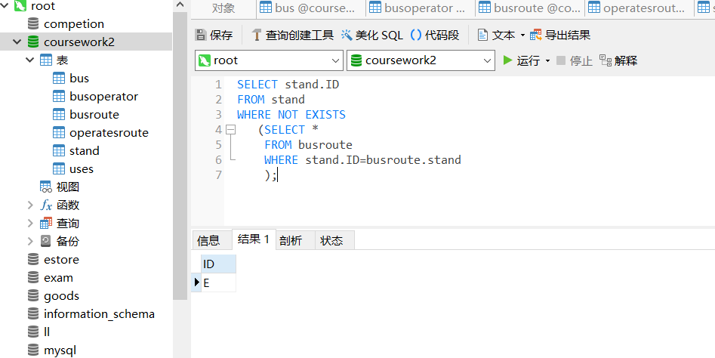

**B Code:**

select stand.ID

From stand

WHERE NOT EXISTS

(

SELECT *

FROM busroute

WHERE stand.ID=busroute.stand

);

c) Give an alphabetical ordered list of the types of bus that can fit onto Stand A. Hint: A bus can fit onto a stand if it doesn’t exceed the maximum length allowed for that stand. (4 marks)

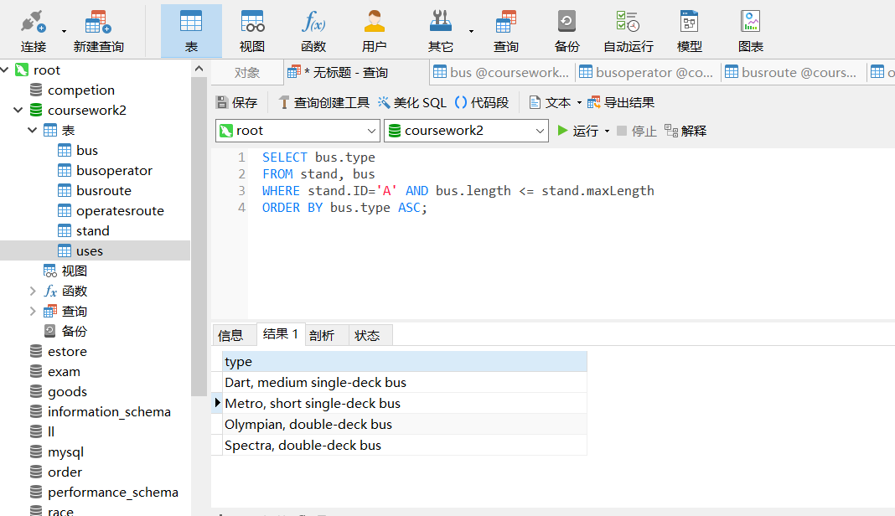

**C Code:**

SELECT bus.type

FROM stand,bus

WHERE stand.ID='A' AND bus.length <= stand.maxLength

ORDER BY bus.type ASC;

d) What types of bus are the longest? (3 marks)

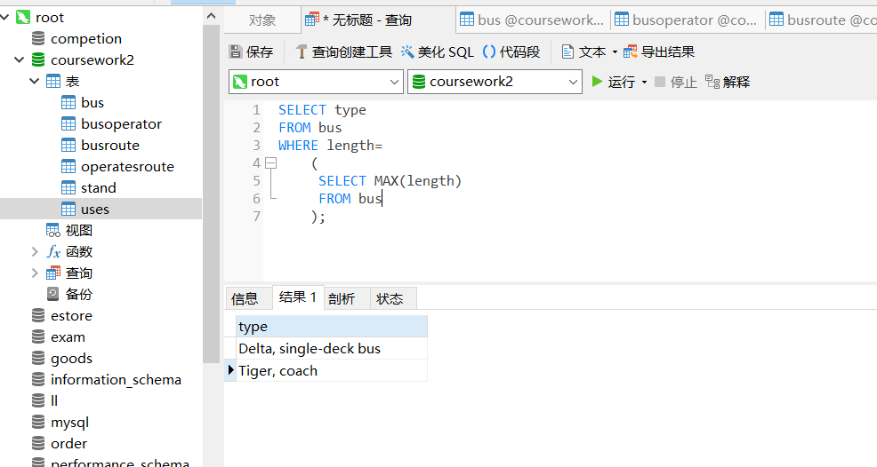

**D Code:**

SELECT type

FROM bus

WHERE length=

(

SELECT MAX(length)

FROM bus

);

e) For all stands which have regular departures, list the stand letter and the number of routes that use that stand. (2 marks)

Important note: Query f) below will change the answer to this question. If for some reason you have attempted query f) before query e) you MUST state this before showing the screenshot of the query e) results.

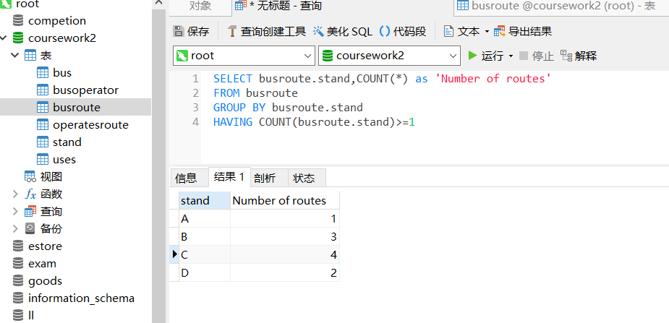

**E Code:**

SELECT busroute.stand, COUNT(*) as ‘Number of routes’

FROM busroute

GROUP BY busroute.stand

HAVING COUNT(busroute.stand)>=1

f) Stand C is getting too congested, so it is planned to move service 355 to use Stand D instead. Show how you could do this with SQL. Note that simply opening DBeaver and changing the data in its datasheet view is not sufficient to score marks for this question, you must use an SQL query. (4 marks)

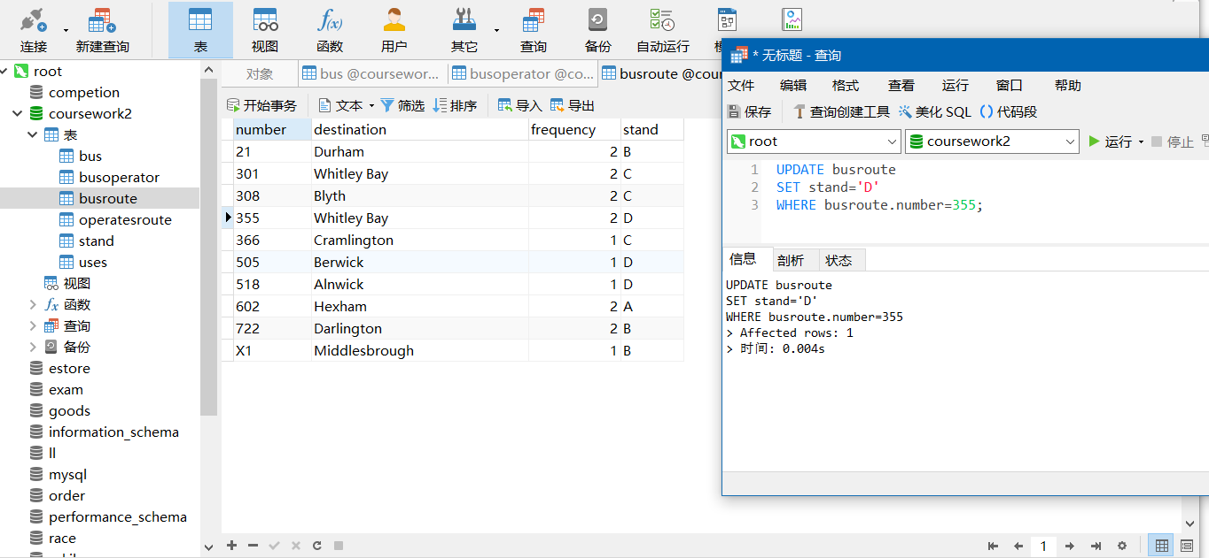

**F Code:**

UPDATE busroute

SET stand='D'

WHERE busroute.number=355;

g) A passenger has dropped something getting off a bus in Stand B and wants to contact the bus operators serving that stand in case their lost property has been handed in. What are the e-mail addresses they need to contact? You should only include the e-mail address and no other contact information in your answer and express the answer as simply as you can. (4 marks)

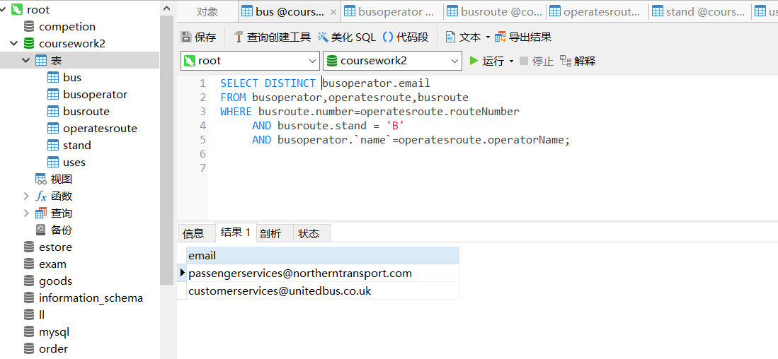

**G Code:**

SELECT DISTINCT busoperator.email

FROM busoperator,operatesroute,busroute

WHERE busroute.number=operatesroute.routeNumber

AND busroute.stand = 'B'

AND busoperator.`name`=operatesroute.operatorName;

h) How many bus journeys per hour are operated by Coastline? Hint: Think about how to work this out and then look back at the slides on arithmetic in SQL queries. (5 marks)

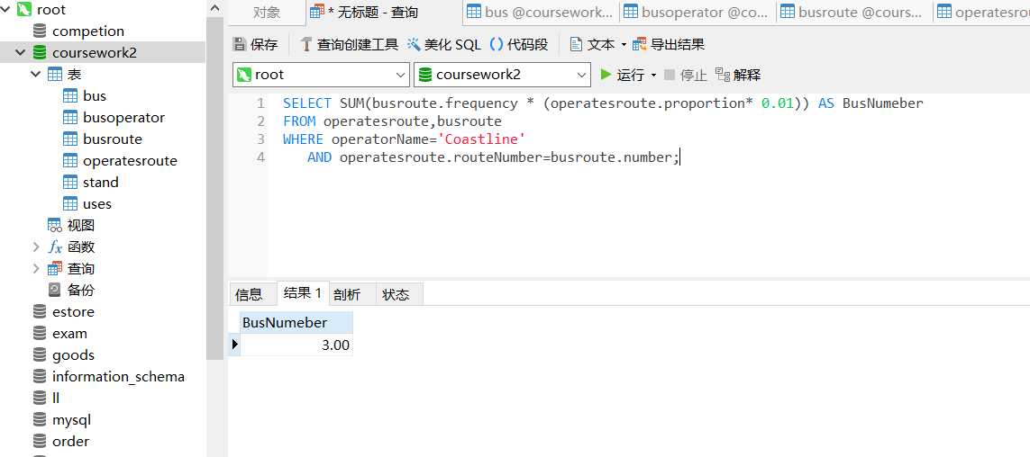

**H Code:**

SELECT SUM(busroute.frequency * (operatesroute.proportion* 0.01)) AS BusNumeber

FROM operatesroute,busroute

WHERE operatorName='Coastline'

AND operatesroute.routeNumber=busroute.number;

i) Give the type and length of all buses which contain the word “Dart” in the type. (4 marks)

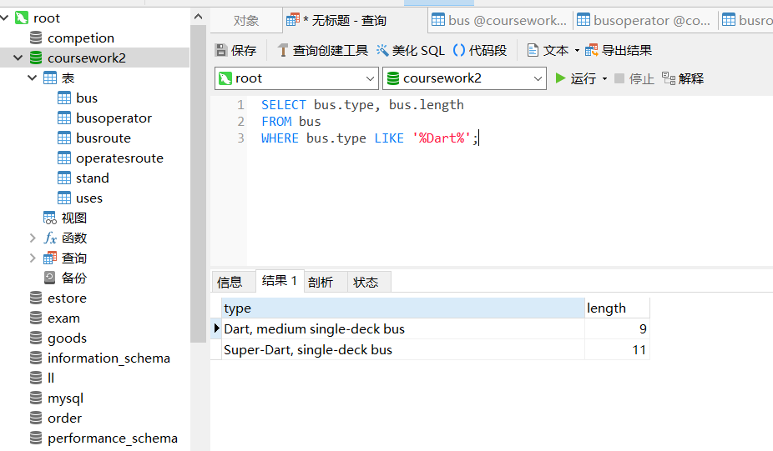

**I Code:**

SELECT bus.type, bus.length

FROM bus

WHERE bus.type LIKE '%Dart%';

j) Route 602 to Hexham departs from Stand A. See if you can write a query to show what types of bus may be used on this route. Hint: This query is quite challenging hence it is worth more marks than the rest so consider it carefully and allow plenty of time. It is not just 6 marks or 0 marks so if you’re unfortunately unable to finish this query you are strongly advised to submit what you have done as it may well still score some marks. (6 marks)

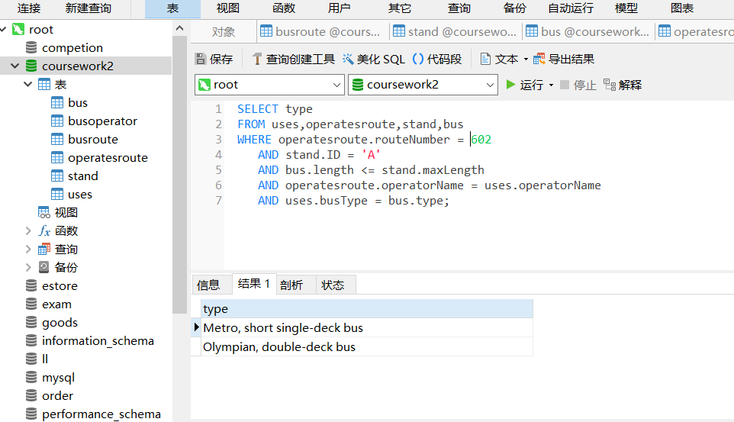

**J Code:**

SELECT type

FROM uses,operatesroute,stand,bus

WHERE operatesroute.routeNumber = 602

AND stand.ID = 'A'

AND bus.length <= stand.maxLength

AND operatesroute.operatorName = uses.operatorName

AND uses.busType = bus.type;

**Part2**

**1.**

According to the assumption ‘A developer has suggested adding the attributes “Agent name”, “Agent phone number”and “Agent Email” for each agent to the “Operator” entity.’ There are many agents in the operator entity and add Agent name etc. into the agent attribute. The form of the following table appears.

|  |  |  |  |  |  |  |
| --- | --- | --- | --- | --- | --- | --- |
| name | adderss | email | phone | Agent | | |
| Agentname | Agent phone number | Agent Email |
|  |  |  |  |  |  |  |

Because the definition of 1NF is that it is the two-dimensional array table, and the attributes cannot be divided. Obviously, the agent attribute is divided into three other attributes. So this suggestion is not 1NF.

**2.**

As I said before, the requirement of 1NF is that attributes cannot be divided. So this table needs to be changed to the following form.

|  |  |  |  |  |  |  |
| --- | --- | --- | --- | --- | --- | --- |
| **#**Agent name | Agent phone number | Agent Email | #name | address | email | phone |
|  |  |  |  |  |  |  |

Since there are no other necessary attributes in the topic, only known attributes are discussed. Where agent name and name (busroute) is the primary key and others are no non-key attributes.

**3.**

Because 2NF is to ensure that each column of the database is related to the primary key, not only a part of the primary key. Because an operator has one or more agents. So split the above table into two tables. The table is shown below.

Agent Table

|  |  |  |  |
| --- | --- | --- | --- |
| #Agent name | name | Agent phone number | Agent Email |
|  |  |  |  |

busoperator Table

|  |  |  |  |
| --- | --- | --- | --- |
| #name | phone | address | email |
|  |  |  |  |

Agent name is the primary key in Agent table and name is primary key in busoperator table. Among them, name, agent, phone number, agent and email are completely dependent on agent name. While the attributes of phone, address and email in the busoperator table are completely dependent on name. So, it’s 2NF. And there is no transitive dependencies. So it's 3NF.